Certificate of Analysis

General properties:
Name： PDLLA5000-PEG5000-COOH
Molecular Weight： PEG MW:5000 PDLLA MW:5000
Cat.#： R-1056-55K
Lot.#： RP0162761
Manufacture Date： 2016.06.27
Date of Analysis： 2016.06.27
Recommended Retest date： 2017.06.27
Stability： 12 months
Storage： -20°C in the dark

Structure
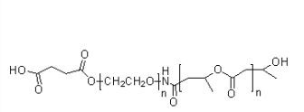

Items | Specification | Results
Appearance | White/ Off-white solid | White solid
¹H NMR | Identical to the structure | Identical to the structure
Foreign Material | None | None
Substitution | ＞90% | 90%
Report Date: 2016.06.27

This product is for research use only, Not for human or animal use

